**Pico Boulevard Social Climate Analysis**

**Outline**

Expected Outcomes of this SCA

1. Identify social and cultural factors that influence how people use transportation facilities in the Pico Boulevard project area.
2. Work with community members and resident leaders to identify meaningful ways to preserve community assets and to address socio-cultural barriers between transportation projects and community members.
3. Inform the overall scope, implementation timeline, and engagement strategy.
4. Identify direct service providers, advocates and programmatic needs that should be considered throughout and after the life of the project.

Project Overview

Pico Boulevard was selected as a Vision Zero priority corridor from the 2017 High Injury Network. At that time, the segment of Pico Boulevard between Western Avenue and Union Avenue was a priority. A different segment of Pico Boulevard, between Western And 2nd Avenue was adopted as a priority corridor in 2019. Since that time, Pico Boulevard between 4th Avenue and Union Avenue has been highlighted as a priority corridor in the new 2024 High Injury Network.

The Pico Boulevard Safety and Mobility Project (Project) is a 3.5-mile segment between Crenshaw Boulevard and Figueroa Street. The Project proposes to reconfigure this segment in order to improve safety and enhance connections in the City’s bicycle network. Pico Boulevard has also been identified as an Olympics-serving priority corridor that will support access to events at the Convention Center in Downtown LA.

* A map of the project boundaries should be included in this section

Need Statement

Between 2014 and 2023, there were 76 serious traffic collisions on Pico Boulevard between Crenshaw Boulevard and Figueroa Street that resulted in severe injury or death. 68% of these collisions involved people walking or biking and all 11 people killed were pedestrians.

The Project is intended to improve safety on Pico Boulevard and reduce the number of severe and fatal collisions occurring on the street. The Project is also intended to close a gap in the City’s bicycle network by implementing bike lanes on Pico between Crenshaw Boulevard and Figueroa Street, connecting to existing bike lanes on 4th Avenue and Figueroa Street.

* Indicate all city agencies responsible for project delivery and the components that they are responsible for.

Section One: Project Area and Community Background

Demographics

In order to further understand the socio-economic dynamics specific to the project, the LADOT project team analyzed a broader set of demographic data within the  ½-mile radius surrounding Pico Boulevard from Crenshaw Boulevard to Figueroa Street (Project Area). The analysis focused on demographic indicators such as language access, poverty, housing and displacement, and transportation and commuting. The results of the additional analysis help to underscore community needs, and allows for the project team to better tailor engagement.

Age, Race, and Ethnicity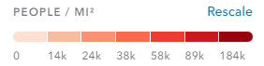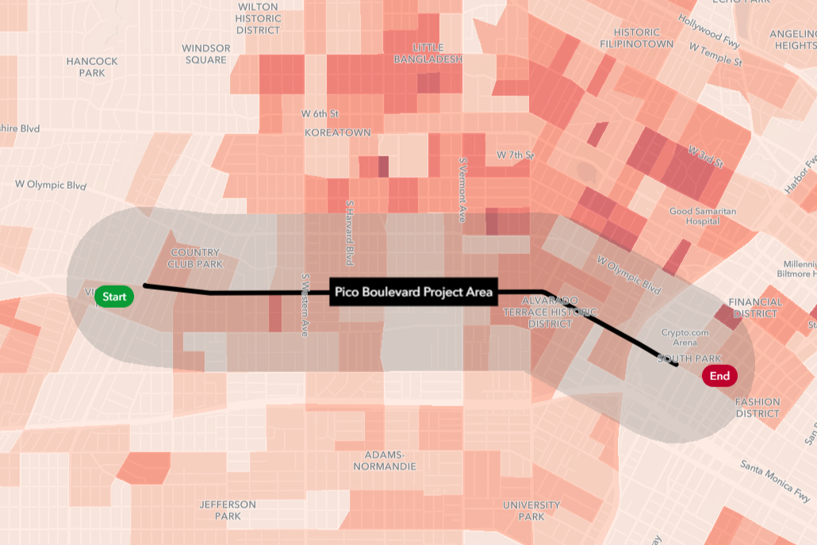

***Figure 1: Population.*** *People living per square mile, by block group. 5-year ACS: 2018-2022.*

Roughly 94,000 people live within the ½ mile radius Project Area. As shown on Figure 1, the Project Area is less densely populated than the heart of Koreatown to the north. Block groups in the Project Area around Western Avenue and Hoover Street have a slightly higher population density than the rest of the Project Area.

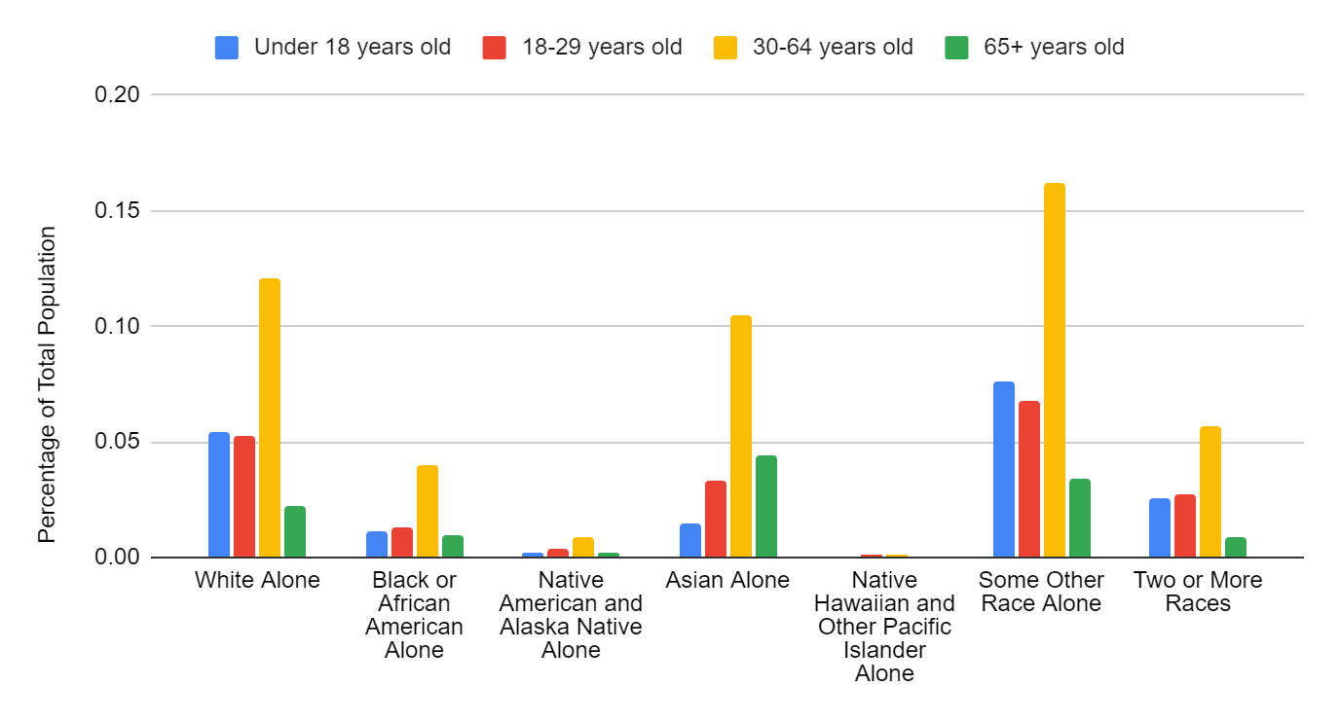***Figure 2: Age and Race.*** *Age By Race (Universe: Total Population). From table B01001 in the American Community Survey 5-year; 2018-2022, using Census Tracts. Stats estimated by geospatial intersection.*

An estimated 63.1% of the Project Area population is of Hispanic/Latino origin. Figure 2, above, shows the breakdown of population age by race and Figure 3, below, shows the breakdown of race by Hispanic/Latino origin. Half (49.5%) of the Project Area population is between 30 and 64 years old. A small proportion (12.4%) of the population is 65 or older, and 18.3% is under 18. There appears to be a disproportionately large number of older Asian residents, as well as a large number of young Hispanic/Latino residents.

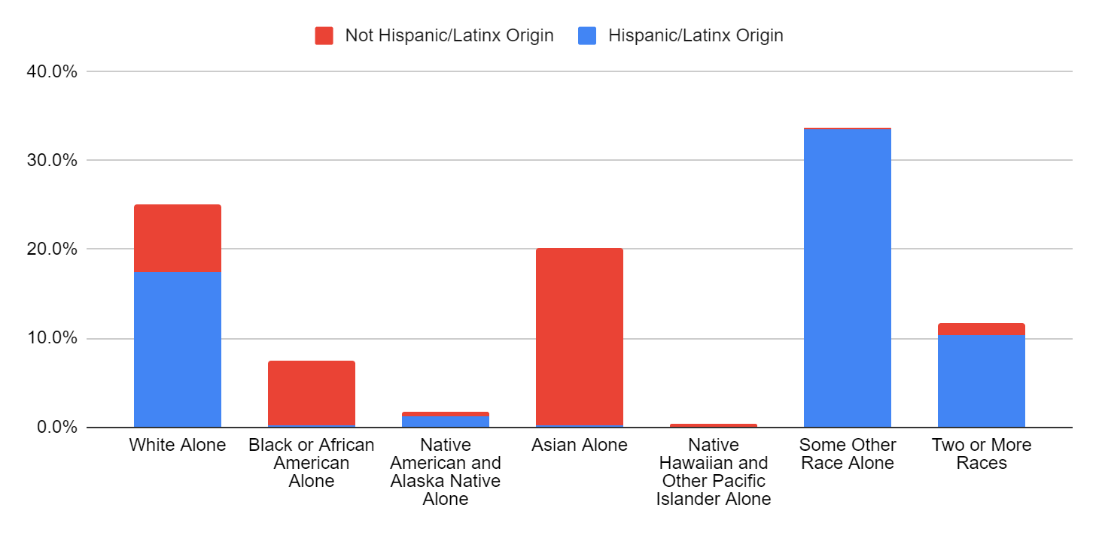

***Figure 3: Hispanic or Latino Origin.*** *Hispanic Or Latino Origin By Race (Universe: Total Population). From table B03002 in the American Community Survey 5-year; 2018-2022, using Census Block Groups. Stats estimated by geospatial intersection.*

Language and Digital Access

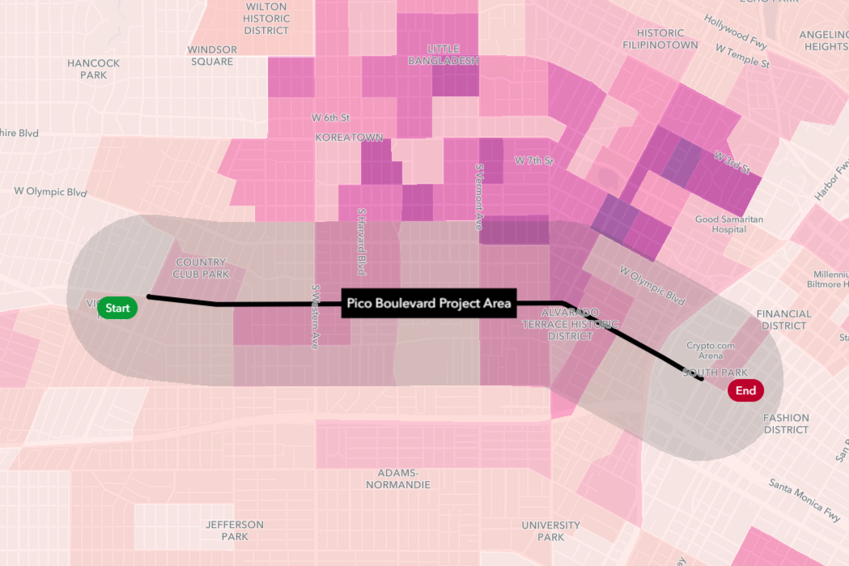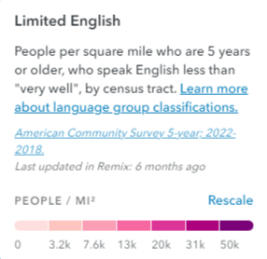***Figure 4: Limited English****. Language People per square mile who are 5 or older, who speak English less than “very well,” by Census tract. 5-year ACS: 2018-2022.*

Language access varies throughout the Project Area, with about 44% of residents reporting that they speak English less than “very well”. Census tracts around Hoover Street especially have a higher concentration of residents with a limited understanding of the English language. This area is part of the Pico-Union neighborhood. Also within the ½ mile project area radius is the southern border of Koreatown. The tracts in this neighborhood have a notably higher concentration of residents with a limited understanding of English.

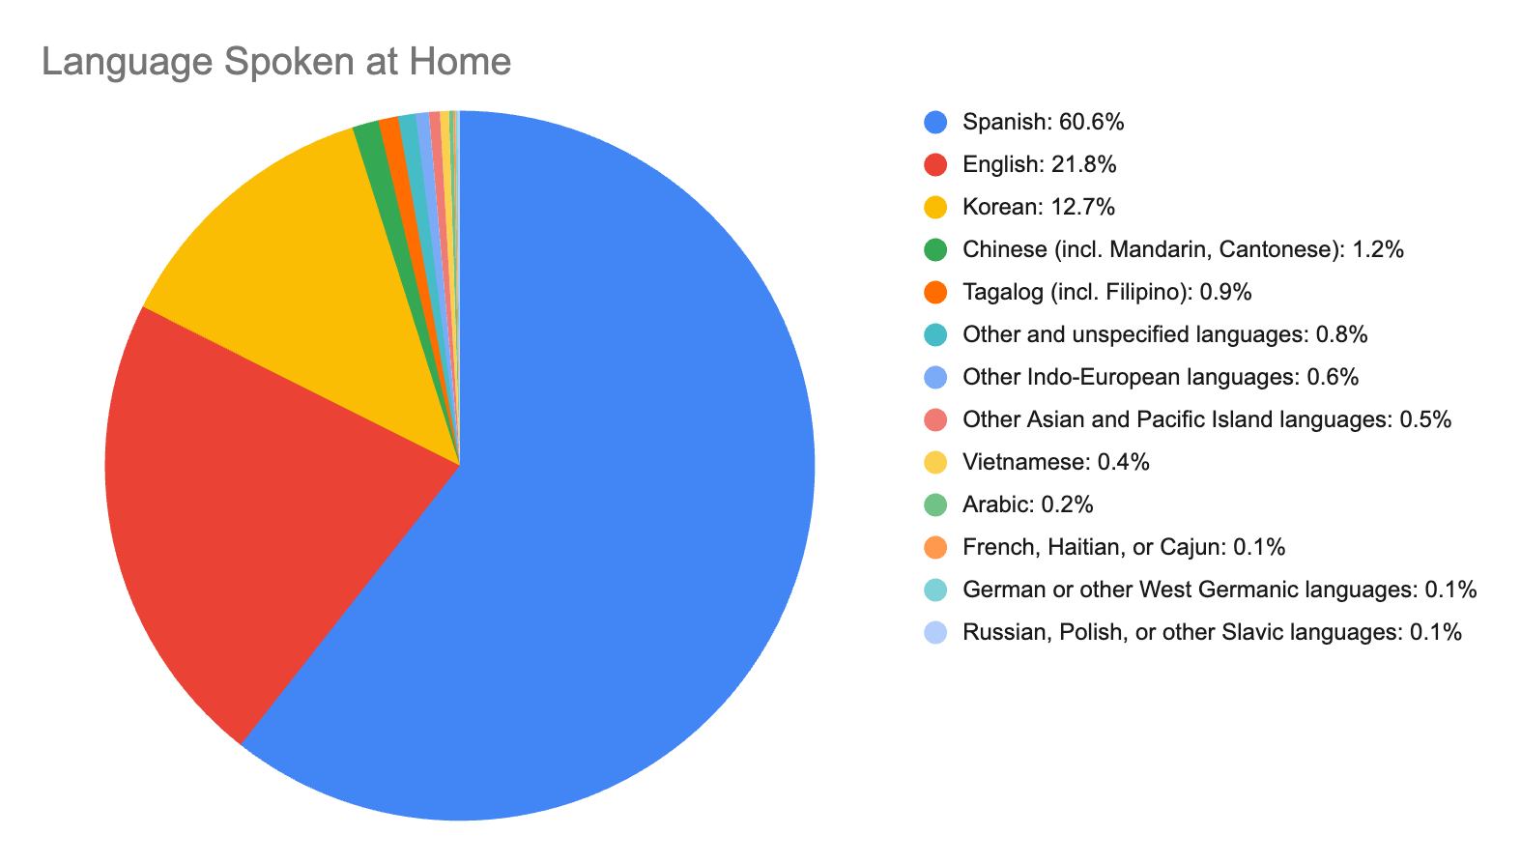

***Figure 5: Language Spoken At Home.*** *Language Spoken at Home For The Population 5 Years And Over (Universe: Population 5 Years and Over). From table C16001 in the American Community Survey 5-year; 2018-2022, using Census Tracts. Stats estimated by geospatial intersection.*

Figure 5 breaks down English language access by language spoken at home for the ½ mile radius surrounding the Project Area. Spanish is overwhelmingly the primary language spoken at home (60.6%), followed by Korean (12.7%). Project materials should be made available in Spanish and Korean.

According to the 2018-2022 5-year ACS, most households in the Project Area (84.4%) have access to a computer and Internet. 11.5% of households have access to a computer but no Internet subscription, and 3.7% have no computer. The project team should take into consideration the roughly 15% of households that do not have easy access to online materials.

Displacement Risk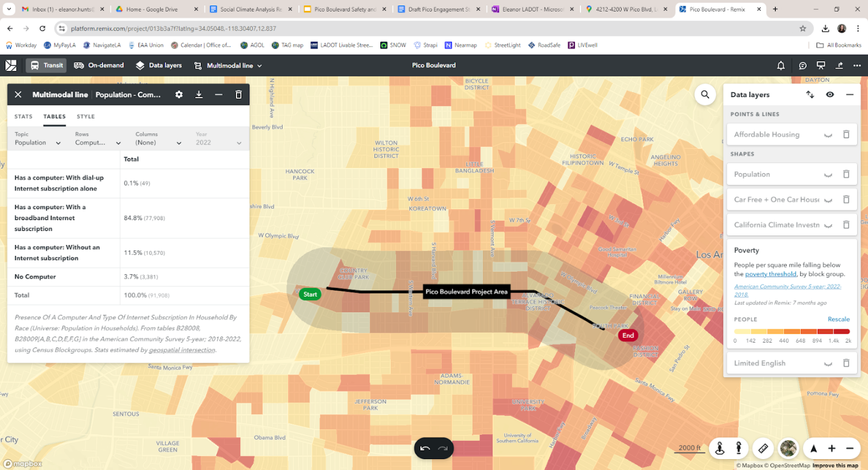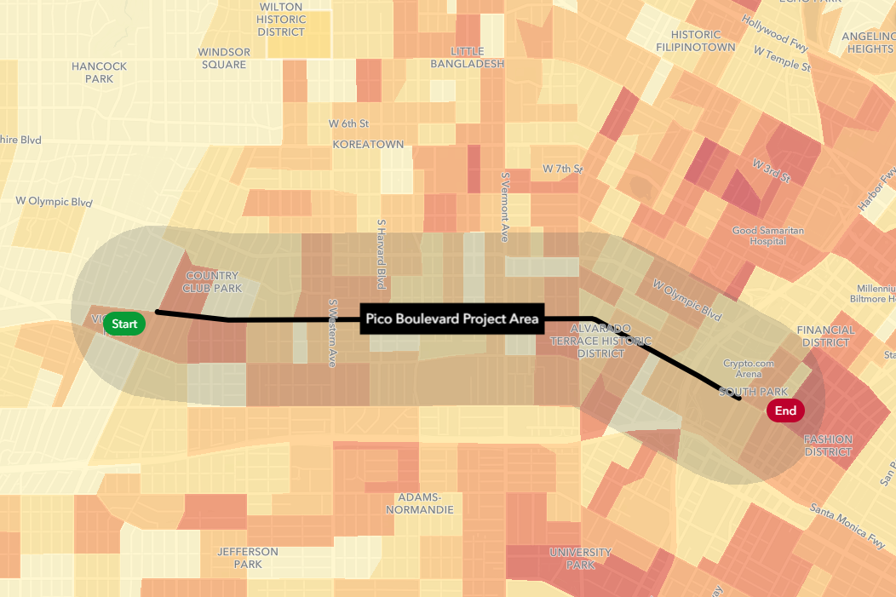

***Figure 6: Poverty.*** *People per square mile falling below the poverty threshold by block group. 5-year ACS: 2018-2022.*

51% of people in the ½ mile Project Area are within 200% of the poverty threshold. 23% of residents fall below the poverty threshold. The highest concentrations of these residents are located:

* North of Pico Boulevard between Crenshaw Boulevard and Norton Ave
* South of Pico Boulevard between West Boulevard and Arlington Avenue (either side of Crenshaw Boulevard)
* South of Pico Boulevard between Westmoreland Avenue and Union Avenue (either side of Hoover Street)
* North and south of Pico Boulevard, east of Figueroa Street

5-year ACS estimates (2018-2022) show that a large majority (86.4%) of residents in the Project Area are renters as opposed to homeowners.

The table below summarizes rent burden in the Project Area. About 54% of renter households (shaded in yellow) spend more than 30% of their income on rent. Almost 30% spend at least half of their income on rent. While housing is traditionally deemed “affordable” when it consumes no more than 30% of a household’s income, an “affordable” housing unit may not be location-efficient. According to the Center for Neighborhood Technology, transportation is usually a household’s second-largest expense. Those who live in the Project Area may spend an even greater portion of their income on their location once transportation costs for travel between work and other essential destinations are factored in.  Transportation within the Project Area is discussed later in this analysis.

|  |  |
| --- | --- |
| **Percent of Household Income Spent on Rent** |  |
| **Less than 20.0%** | 19.5% |
| **20.0%-24.9%** | 9.0% |
| **25.0%-29.9%** | 11.5% |
| **30.0%-34.9%** | 9.6% |
| **35.0%-39.9%** | 6.3% |
| **40.0%-49.9%** | 8.9% |
| **50.0% or more** | 29.6% |

*Household Income By Gross Rent As A Percentage Of Household Income In The Past 12 Months (Universe: Renter-Occupied Housing Units). From table B25074 in the American Community Survey 5-year; 2018-2022, using Census Block Groups. Stats estimated by geospatial intersection. Rent burden for 5.6% of renter households was not computed.*

**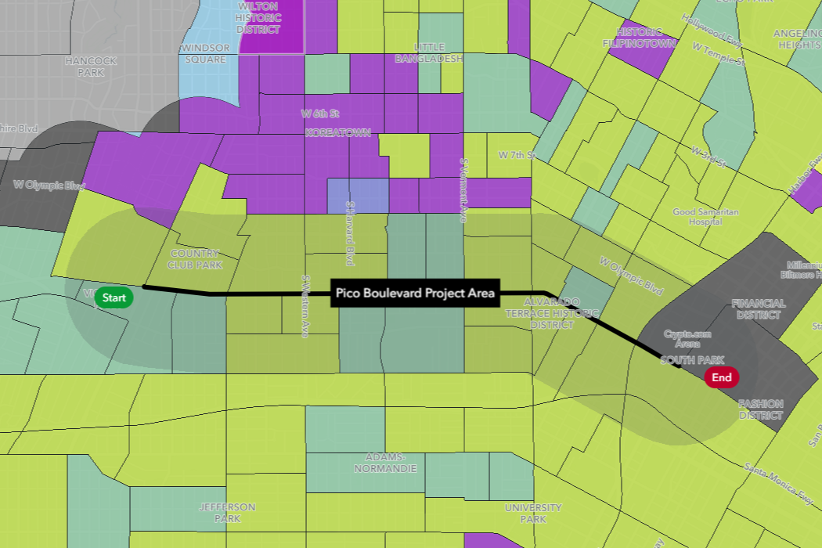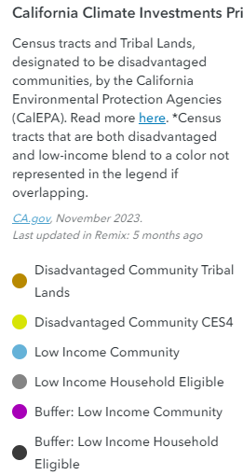*Figure 7: California Climate Investments Priority Populations (2022).*** *Disadvantaged communities, based on CES version 4.0 and CalEPA disadvantaged communities identification. Census tracts that are both disadvantaged and low-income blend to a color not represented in the legend if overlapping.*

The California Climate Investments Priority Population data defines different ways to look at community vulnerability by analyzing factors in addition to economic indicators. Disadvantaged communities here refers to the areas throughout California which most suffer from a combination of economic, health, and environmental burdens. Most of the Census tracts within a ½ mile radius of the project fall under both disadvantaged and low-income, primarily those between Harvard Boulevard and Vermont Avenue (both north and south of Pico Boulevard), and those south of Pico Boulevard and west of Arlington Avenue.

Based on the results of both sets of data (poverty and California Climate Investments Priority Populations), and the goal of connecting with vulnerable populations that have historically been excluded from the planning process, the project team should be sure to reach the communities south of Pico Boulevard near Arlington Avenue, and north and south of Pico Boulevard between Normandie and Vermont.

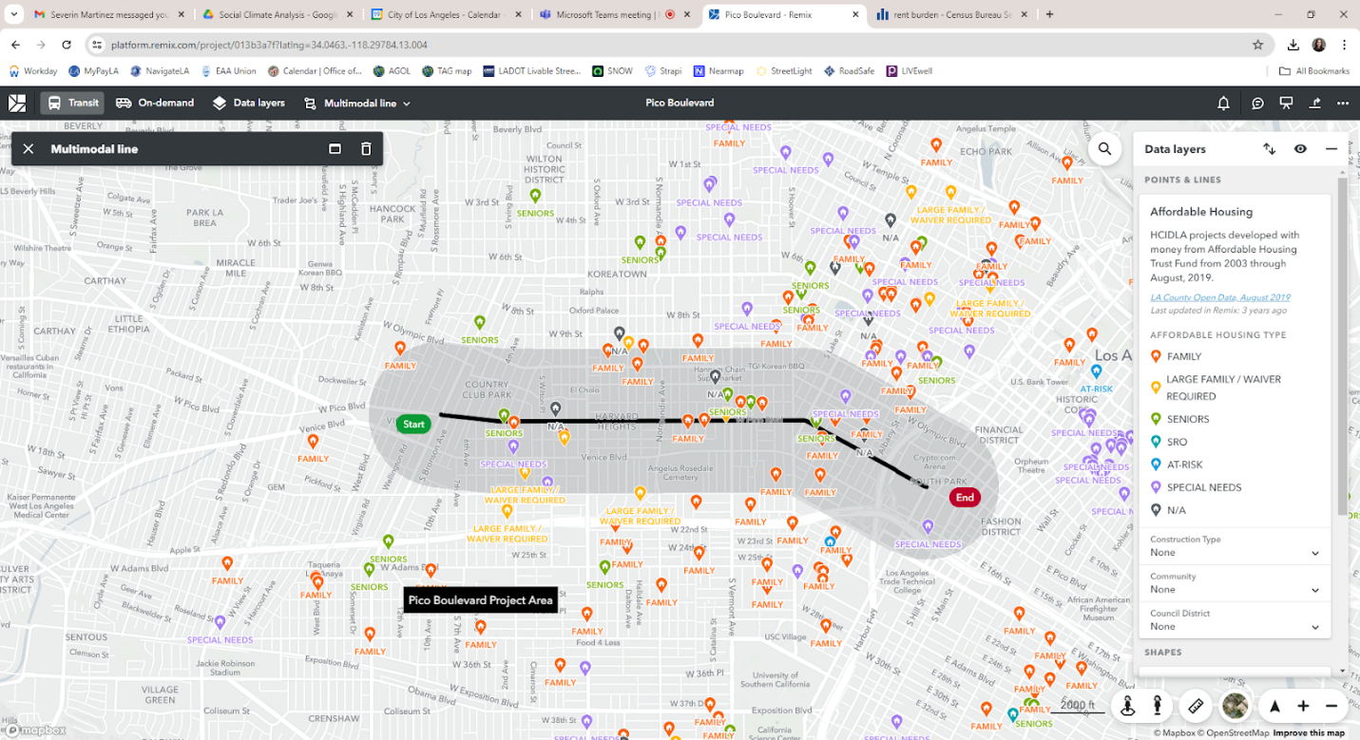***Figure 8: Affordable Housing.*** *City of LA affordable housing units developed from 2003-2019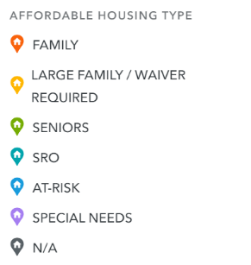*

Figure 8 shows the locations of various types of affordable housing units. There is a small concentration of affordable family housing and affordable senior housing near Vermont Avenue, as well between Alvarado Street and Union Avenue. The project team should attempt to reach out to these units to ensure they are aware of the project and can participate in the planning process.

Transportation and Commuting

**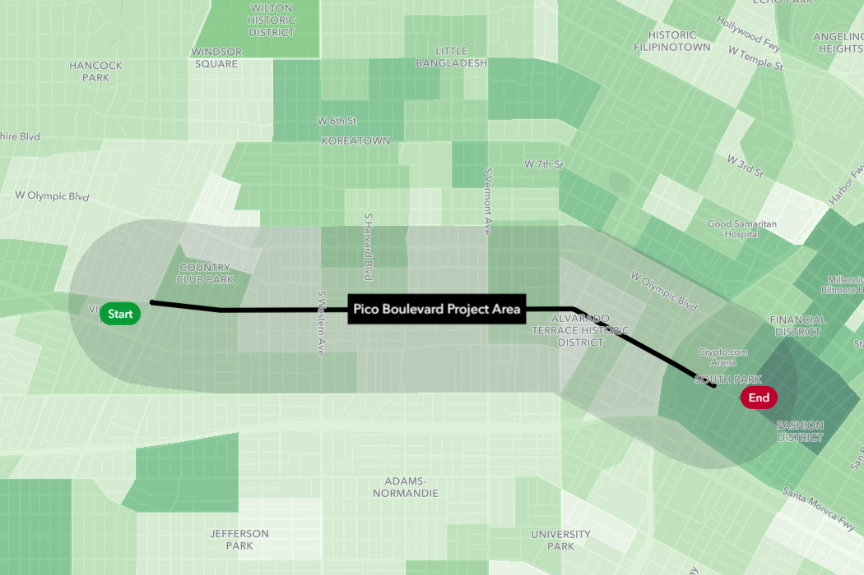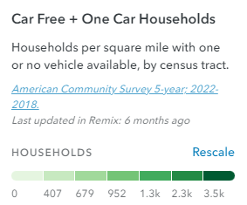*Figure 9: Household Vehicle Access.*** *Households per square mile with one or no vehicle available, by Census tract. 5-year ACS: 2018-2022.*

Figure 9 shows the concentration of households with limited vehicle access. Access varies within the ½ mile Project Area. 43.9% of households report that they have access to one vehicle, and 23% (about 3,800 households) are car-free. Some of this may be by choice, but given that the majority of the Project Area is disadvantaged and low-income, there may be some correlation between lack of access to personal vehicles and income level. This data can also inform mode choice for this area.

Figure 10, below, shows how well the existing bike network gets people to the places they want to go, per the Bicycle Network Analysis (BNA). The higher the score, the more accessible an area is by bike. Key to the BNA’s methodology is a scoring of network stress. Points are awarded if a person can bike from the Census block in which they live to a Census block containing a common destination (such as a grocery store) using only low-stress routes. As seen in the figure, the lack of bicycle infrastructure and presence of high-stress streets in the Project Area contribute to a low BNA score.

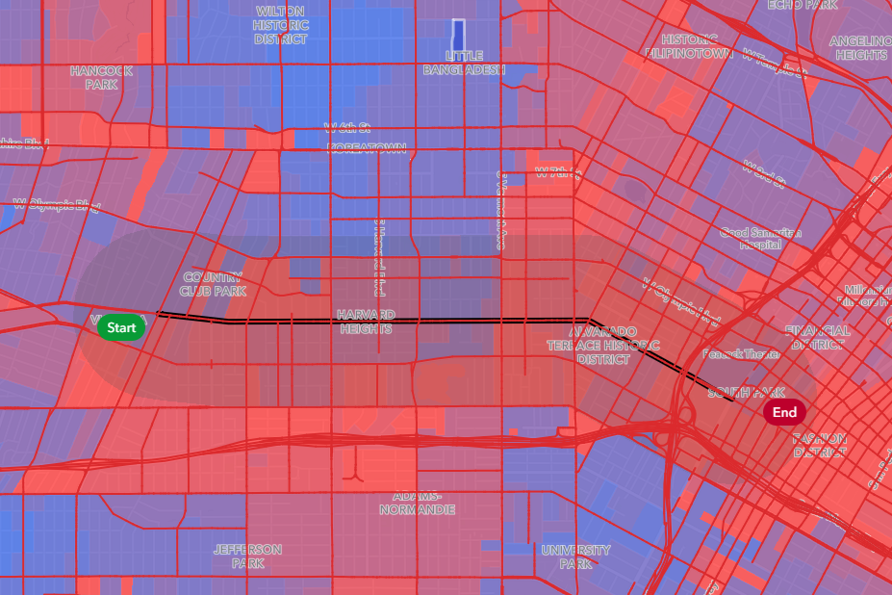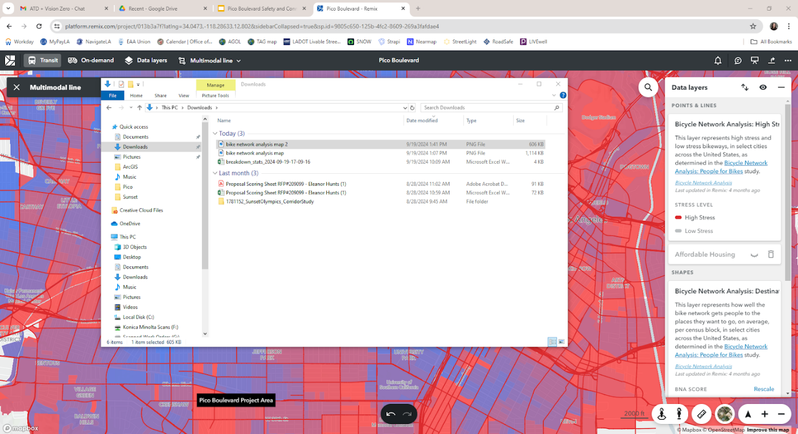***Figure 10: Bicycle Network Analysis.*** *Bicycle Network Analysis: People for Bikes, 2024.*

The Project Area is generally well-served by transit. Metro Bus Line 30 services Pico Boulevard for the extent of the Project. Several other Metro Bus Lines intersect Pico Boulevard within the Project Area, including Metro 2, 204, 206, 207, 210, 603, and 754. LADOT’s Pico Union DASH buses run north-south on Union Avenue in the Project Area.

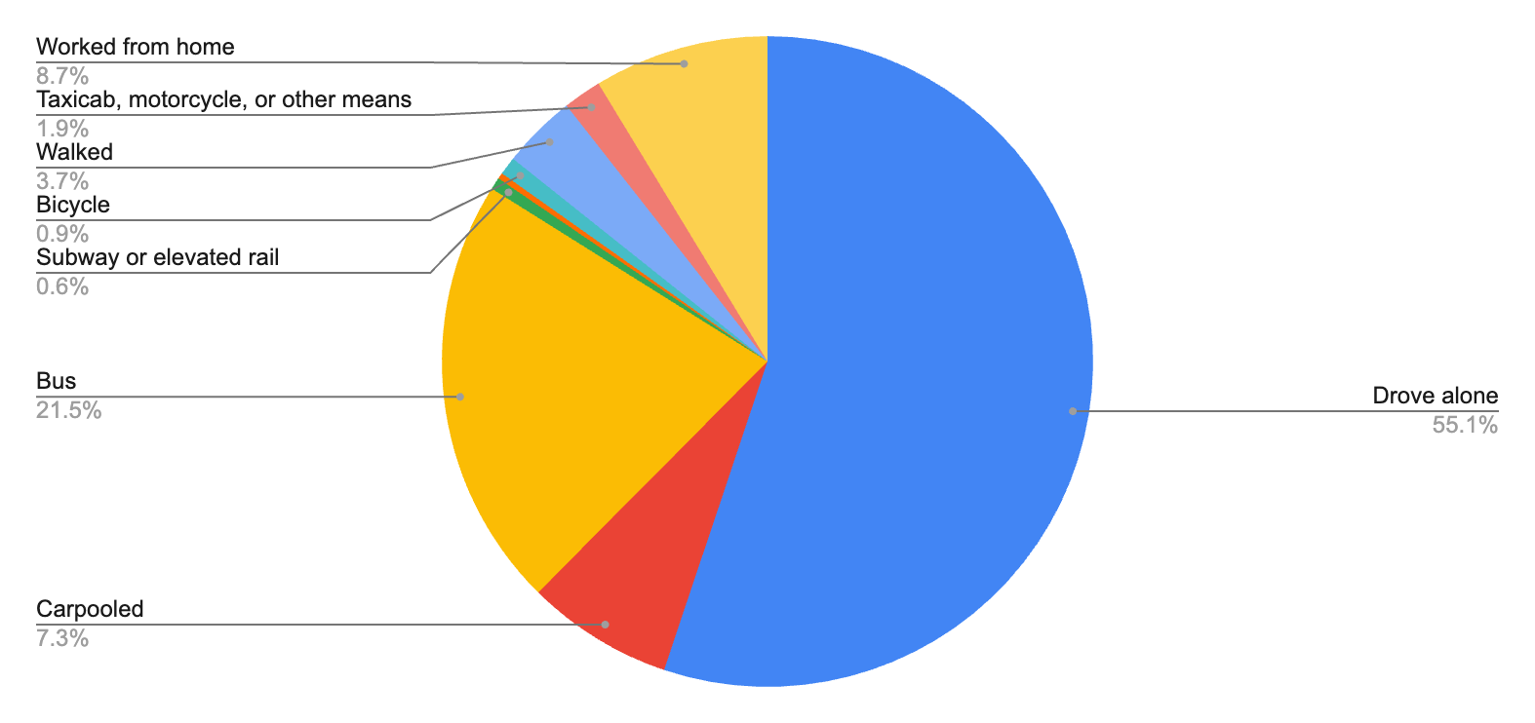

***Figure 11: Commute Mode.*** *Means Of Transportation To Work (Universe: Workers 16+). From table B08301 in the American Community Survey 5-year; 2018-2022, using Census Block Groups. Stats estimated by geospatial intersection. Unlabeled chart section: Light rail, streetcar, or trolley (0.3%).*

Over 60% of the population within the ½ mile radius Project Area drive alone as part of their commute (see Figure 11, above). The data collection period includes 2020-2022, during which some of the population began working from home. For these workers (8.7% of the study area), no alternative mode of transportation is given for their commute. Aside from driving and working from home, taking the bus (21.5%) and carpooling (7.3%) make up the next largest proportions of commute mode. 3.7% of workers living in the study area walk to work, and about 1% ride their bicycle.

Almost two-thirds (65.8%) of the working population within the ½ mile radius Project Area have commutes that are longer than 30 minutes. Only 20.5% of the Project Area working population have a commute time of less than 20 minutes.

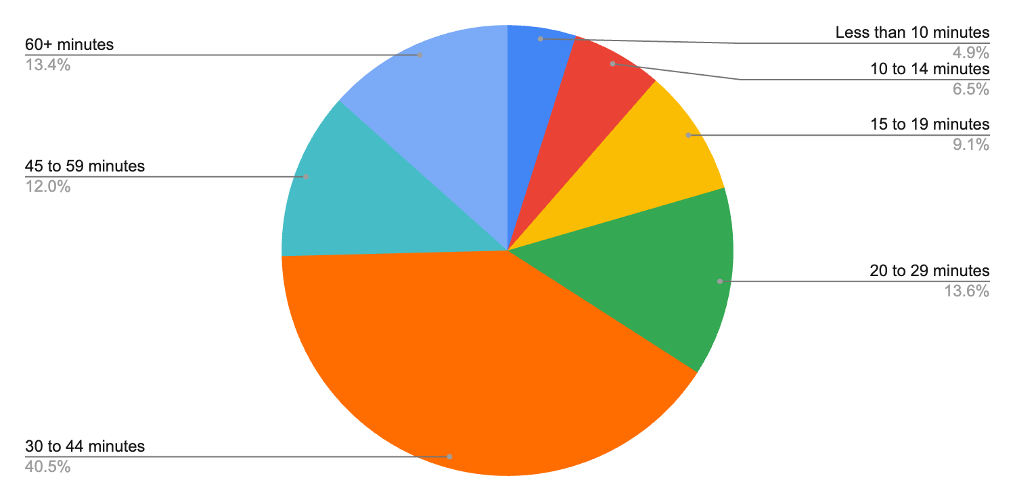

***Figure 12: Commute Length.*** *Means Of Transportation To Work By Travel Time To Work (Universe: Workers 16+ not working from home). From table B08134 in the American Community Survey 5-year; 2018-2022, using Census Block Groups. Stats estimated by geospatial intersection.*

As shown on Figure 13 below, 63.5% of those who carpool or drive alone to work have a commute time above 30 minutes. However, 20.9% of those workers have a commute time less than 20 minutes and could potentially shift their commute to a different mode of transportation.

As stated previously, more than 20% of the working population within the study area takes the bus to work. 86.3% of these workers have a commute time longer than 30 minutes. 29.2% of these workers have a commute time longer than 45 minutes. The project team should be mindful of potential bus service disruptions.

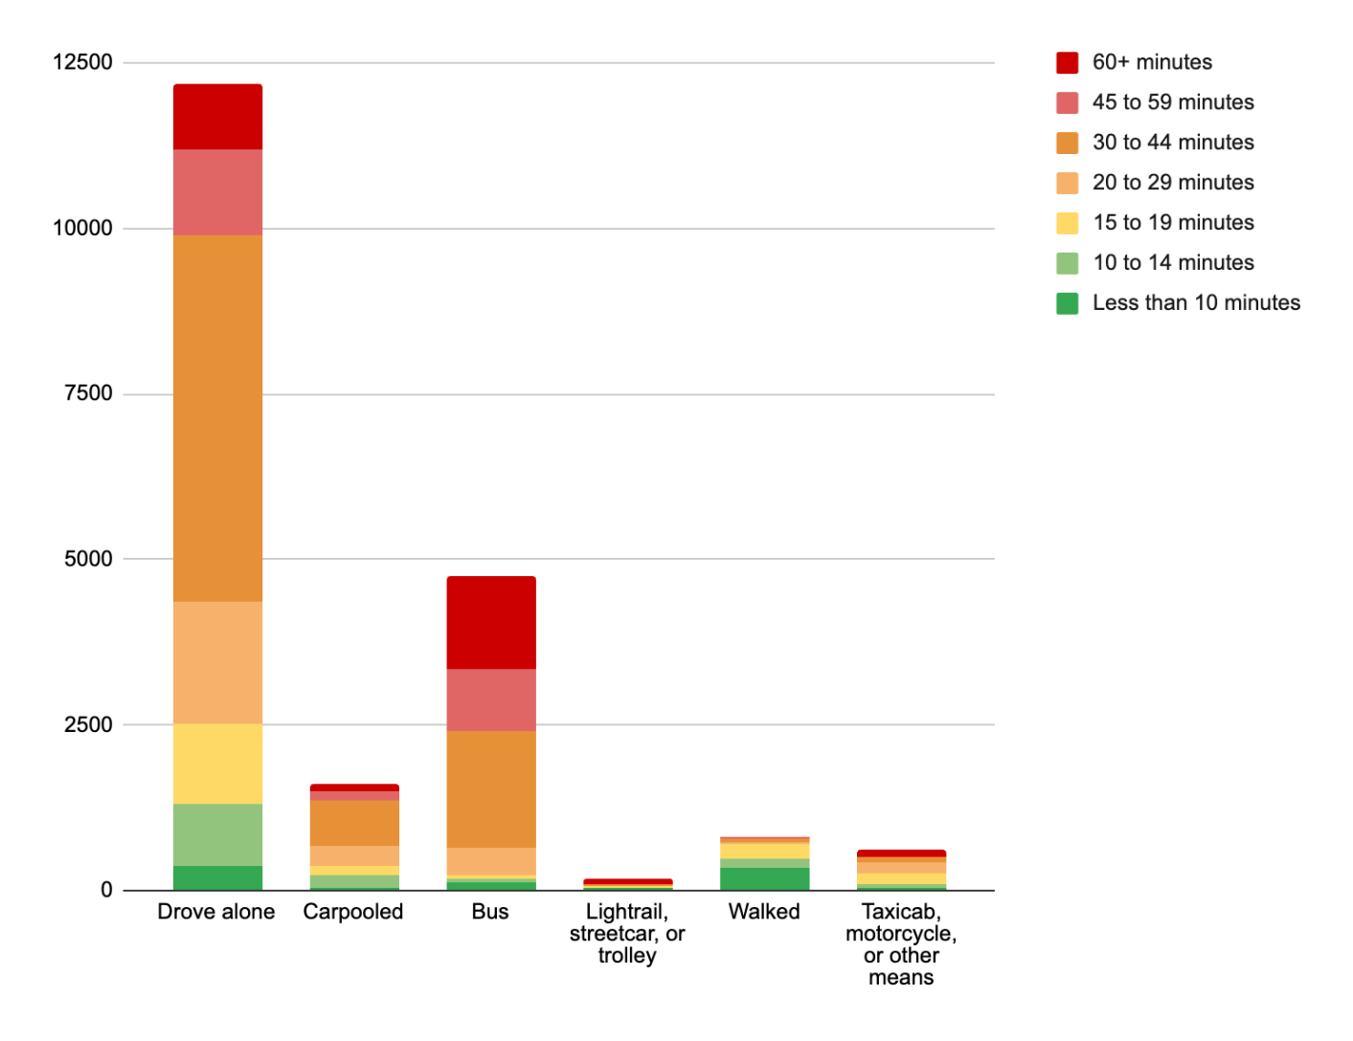***Figure 13: Commute Length by Mode.*** *Means Of Transportation To Work By Travel Time To Work (Universe: Workers 16+ not working from home). From table B08134 in the American Community Survey 5-year; 2018-2022, using Census Block Groups. Stats estimated by geospatial intersection.*

Between 2014 and 2023 there were 76 serious traffic collisions on Pico Boulevard between Crenshaw Boulevard and Figueroa Street that resulted in severe injury or death. 68% of these serious collisions involved people walking or biking, and all 11 people killed were pedestrians. Figure 14 shows the geographic distribution of these collisions. Severe injury collisions (yellow dots) as well as fatalities (red dots) are not isolated to one area, instead indicating an opportunity for a traffic safety intervention.

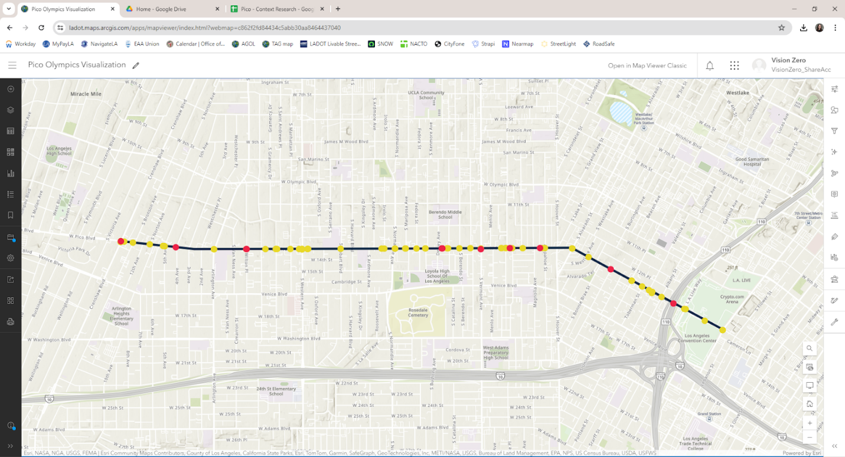**Figure 14: Severe and Fatal Collisions.** Collisions resulting in a fatality (red dots) or severe injury (yellow dots). RoadSafe GIS, 2014-2023.

Community Context

Land Use

Pico Boulevard within the Project Area has a mix of land uses including residential housing units, restaurants, grocery stores, gas stations, auto-oriented shops, places of worship, community-serving businesses, and schools.

The side streets north and south of Pico Boulevard are mostly residential. On the western end of the Project Area, north of Pico Boulevard, is the Country Club Park neighborhood. Since the 1980s, locked gates on Van Ness Avenue, Wilton Place, Gramercy Place, and St Andrews Place have prevented vehicles, pedestrians, and bicyclists from accessing the neighborhood from Pico Boulevard. Other neighborhoods in the Project Area include Arlington Heights, Harvard Heights, Koreatown, and Pico Union.

Businesses

* What types of businesses are represented in this Project Area?

Key Destinations

My Map of key destinations: <https://www.google.com/maps/d/edit?mid=1s5N5x3hjQiMcc6Mt98ucrQSlD9c_jEY&usp=sharing>

Major Stakeholders

* Neighborhood Council(s):
  + Downtown Los Angeles (between Bond St and Figueroa St)
  + Pico Union (between Bond St and Normandie Ave)
  + Olympic Park (between Normandie Ave and 4th Ave)
  + United Neighborhoods (between Normandie Ave and 4th Ave)
  + Country Club Park Neighborhood Association (north of Pico Blvd between Crenshaw Blvd and Western Ave)
* Convention Center/ AEG
* LA Live / Crypto.com
* Figueroa Corridor BID (CD 9)
* Berendo Neighborhood Association
* Harvard Heights Neighborhood Association
* Byzantine Latino Quarter (BID) - shared with CD 10 (Pico, Western to 10 HWY Underpass)
  + Suggest attending one of their quarterly meetings to catch their members at once
  + They have a contracted street clean up crew that is present along Pico 2 x per week
* School communities
  + Pio Pico Middle School
  + Bishop Conaty High School
  + Los Angeles Elementary School
  + Loyola High School
  + Berendo Middle School
  + St. Thomas School
  + University Value Prep Charter
  + Equitas Charters 3 and 4
* LA Metro (Line 30 bus service) Mid City to Little Tokyo
* Koreatown Youth & Community Center

Section Two: Field Observations

[Once the initial Project Area and community background analysis is complete, the project team should spend some time out on the field to validate those findings and explore the existing conditions that may help inform the overall project. Project staff should reach out to Council Offices to join them on the field visit where they can provide additional community context. Council staff can also invite local community representatives where feasible.]

Existing Infrastructure and Use Patterns

What will this project help address? While out on the field, observe existing infrastructure and the use patterns based on the project context. For example, if the project is focused on pedestrian and bike infrastructure improvements, what is the current state of bike lanes and pedestrian crossings? Who is using the existing infrastructure? If there is no existing infrastructure, what should designers consider when introducing new plans?

Project and Engagement Team, Residents, and City/Agency Staff Observations [If Feasible]

Recommended: Walk through the corridor with Council staff and assess any current needs or current issues facing the community that may arise as the project progresses. Are there any community members who represent the area that can assist during the project?  Speak to businesses and community members where opportunities arise to ask questions that may help inform the project (this can be a select few given the engagement process hasn’t fully started yet).

Section 3: Key Recommendations

Accessibility Considerations

Based on the results of the Section 1 and 2, outline the needs for the community members in the Project Area to be able to fully participate including but not limited to:

* Language Access
  + What language(s) should engagement be carried out in?
* Digital Access
  + Will folks be able to access information online? If not, how should we reach folks in other ways?
* Other considerations
  + What other considerations came about through this process? Will community members need childcare to participate? Is there a large senior population that we should consider? What about youth?

Recommended Project Partners & Ambassadors

The following Resident Leaders, Neighborhood Councils, and Community Based Organizations will be directly engaged through this project:

Provide the list of resident leaders, neighborhood councils and community based organizations whose commitment/partnership you will seek. List any potential community leaders who should be identified as community ambassadors for this project.

Business Engagement Recommendations

The following Businesses will be directly engaged through this project:

Provide a list/or overview of the business whose commitment/partnership you will seek.

Scope and Timeline Considerations (if applicable)

Provide an overview of any scope and timeline considerations that should be made given the findings and analyses indicated in this report.

Final Report Date: [DATE]

APPENDIX

Field Observation Photos

[ATTACH ALL FIELD OBSERVATION PHOTOS WITH CAPTIONS AND GEOGRAPHICALLY IDENTIFIABLE NOTATIONS]

Resident Interview Notes

[ATTACH ALL RESIDENT INTERVIEW NOTES CREATED DURING THIS SOCIAL CLIMATE ANALYSIS.]

Public Comments

[ATTACH ALL PUBLIC COMMENTS COLLECTED DURING THIS SOCIAL CLIMATE ANALYSIS.]